At Ashford Park there is a focus on improving writing skills. We have been working on writing across the curriculum and have implemented the Lucy Calkin’s writing program. We began our STEM Noisemaker Project, for example, by discussing, drawing, and writing about how we celebrate the New Year in America and Germany, a Social Studies standard. The students wrote about hopes, plans, and goals for the New Year in German.

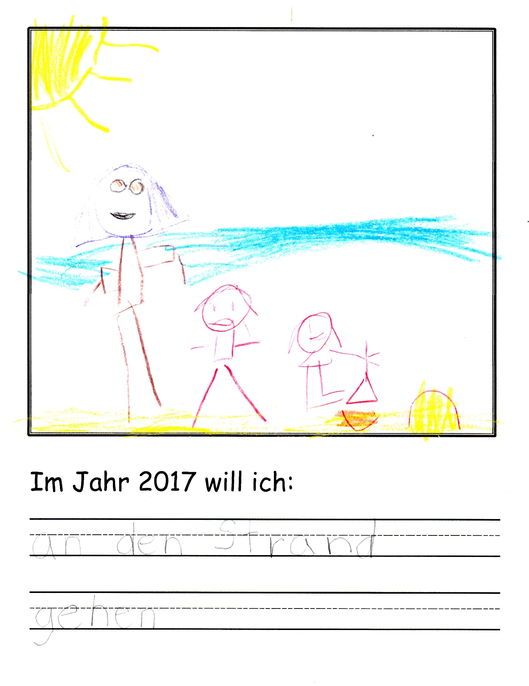

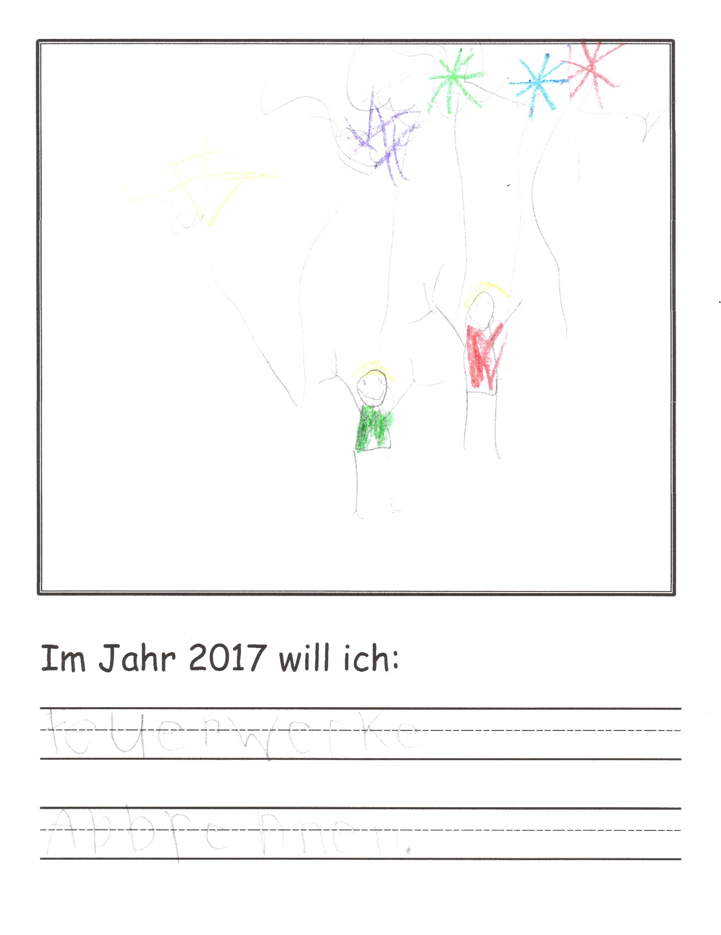

The students discussed noise as a way to celebrate and wrote about their plans to make and uses for a noisemaker.

