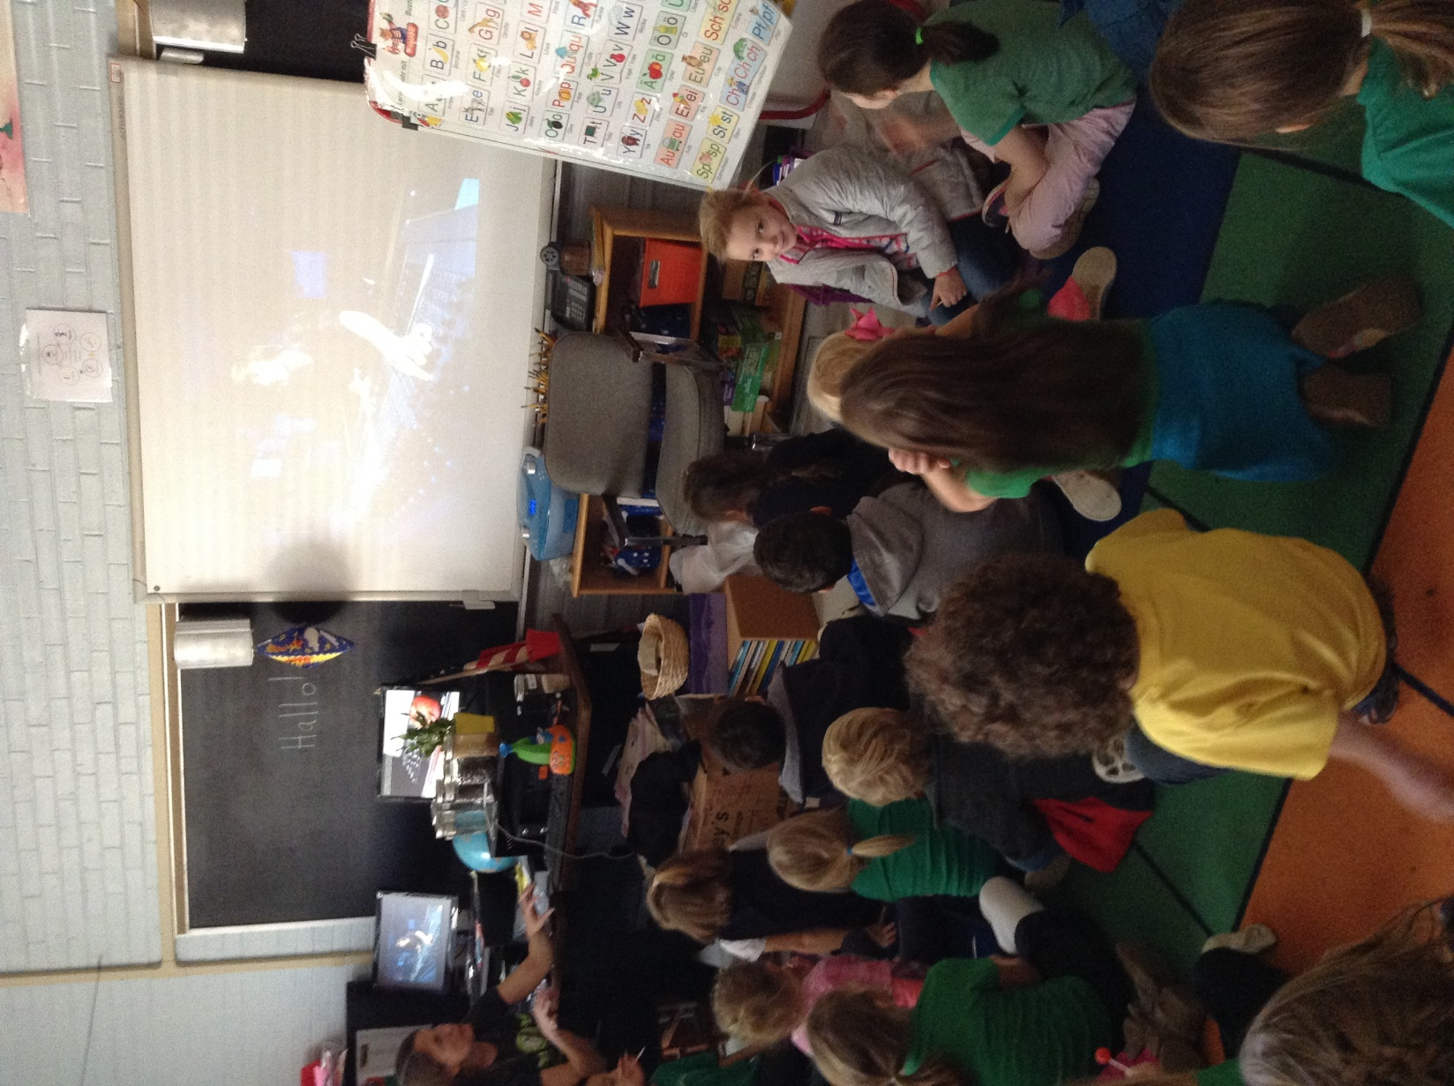

In Kindergarten the noisemaker project led to a discussion of professions involved with the study of sound. We researched online. The children were very excited about the prospects of making sound effects for movies like “Star Wars”.