Name:_______________________ Project Title:_______________________

Ashford Park Elementary
K- 1 STEM Rubric

How Did I Do?
 | Unsatisfactory  Effort  0 points | Approaching Expectations  1 point | Meets  Expectations  2 points | Exceeds Expectations  3 points
Collaboration
.

Creativity

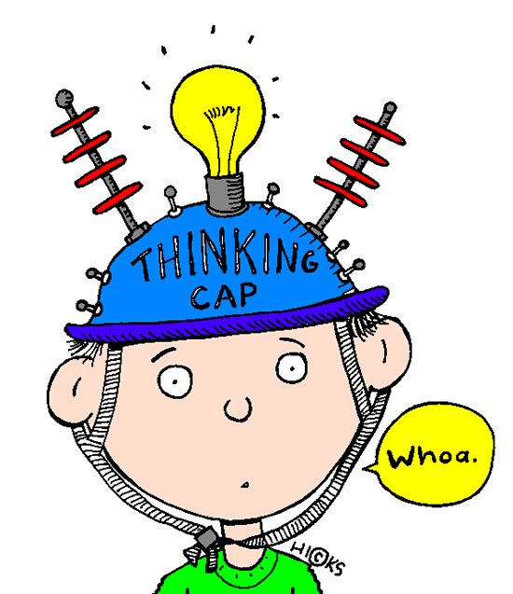
Critical Thinking

Communication

Total Points: _____/12

One thing that I can do to make it better the next time: ________________________
______________________________________________________________________________________________________________________________________________________________________________________________________
Name:_______________________ Project Title:_______________________

Ashford Park Elementary
2-5 STEM Rubric

How Did I Do?

 | Unsatisfactory  Effort  (0 points) | Approaching Expectations  (1 point) | Meets  Expectations  (2 points) | Exceeds Expectations  (3 points)
Collaboration

I worked with my group to achieve a common goal.

Creativity

I used creative thinking to
follow the Engineering Design
Process.

Critical Thinking

I asked questions and used problem solving skills to help
my group find a solution.

Communication

I shared my thoughts and ideas with a positive attitude.
I showed respect to my group members.

Total Points: _____/12

One thing that I can do to make it better the next time: ________________________ ____________________________________________________________________________________________________________________________________
__________________________________________________________________
Name:_______________________ Project Title:_______________________

Ashford Park Elementary
STEM Rubric

Graded By My Teacher

 | Unsatisfactory  Effort  (0 points) | Effort Needs  Improvement  (1 point) | Satisfactory  Effort  (2 points) | Outstanding  Effort  (3 points)
Collaboration

The student worked with his/her group to achieve a common goal.
Creativity

The student used creative thinking and followed the Engineering
Design Process.
Critical Thinking

The student used critical thinking to brainstorm, ask questions, and problem solve to develop a solution.
Communication

The student was able to explain the project, share their thoughts, and reflect upon their work.

Total Points: _____/12

Comments:______________________________________________________________________________________________________________________________________________________________________________________________

